# UWAFT Project

Team: WEiwei chen, chanthida pao, alexey rusev, shengfei sun

Sections of this document:

1. Introduction to all pages about the features
2. User manual to the install these pages

## Features Overview

### Page Hierarchy

Home Page

About Us

History

Our Mission and Vission

Our Fleet

Our Products (Show all cars)

201? Chevrolet Camaro (jump to the car)

2013 Chevrolet Malibu

2009 Saturn Vue

2005 Chevrolet Equinox

1999 Chevrolet Silverado

Team

Calendar

Public Events

Team Schedule

Resources

Savings Calculator

Our Sponsors

Blog

Admin (this is not showing in nav bar)

Team Schedule Management

Public Events Management

Team Member Management

## The Main Page:

**Requirements:** First page that will be seen. Should give first impression and information about project.

**Technologies used:**

* PHP
* HTML5
* Bootstrap Framework
* Photoshop
* Illustrator

**Page Author:** Alexey Rusev

**Overview:**

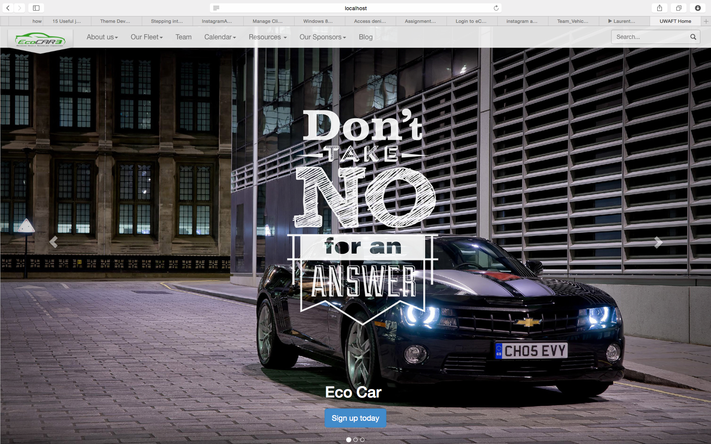

**Features:**

Carousal view of the vehicles, that was created with use of bootstrap template with vector graphic. The carousal will automatically scroll but the images can be manually changed with the right and left arrows on the sides of the image.

## “About us” Page, which contains “History” and “Our Mission and Vision”:

**Requirements:** A page that shows and describes whole history of the UWAFT as long with the goals achieved, future steps and general vision of the project.

**Technology used:**

* PHP
* HTML5
* Bootstrap Frameworks
* JavaScript

**Page Author:** Alexey Rusev

**Overview:**

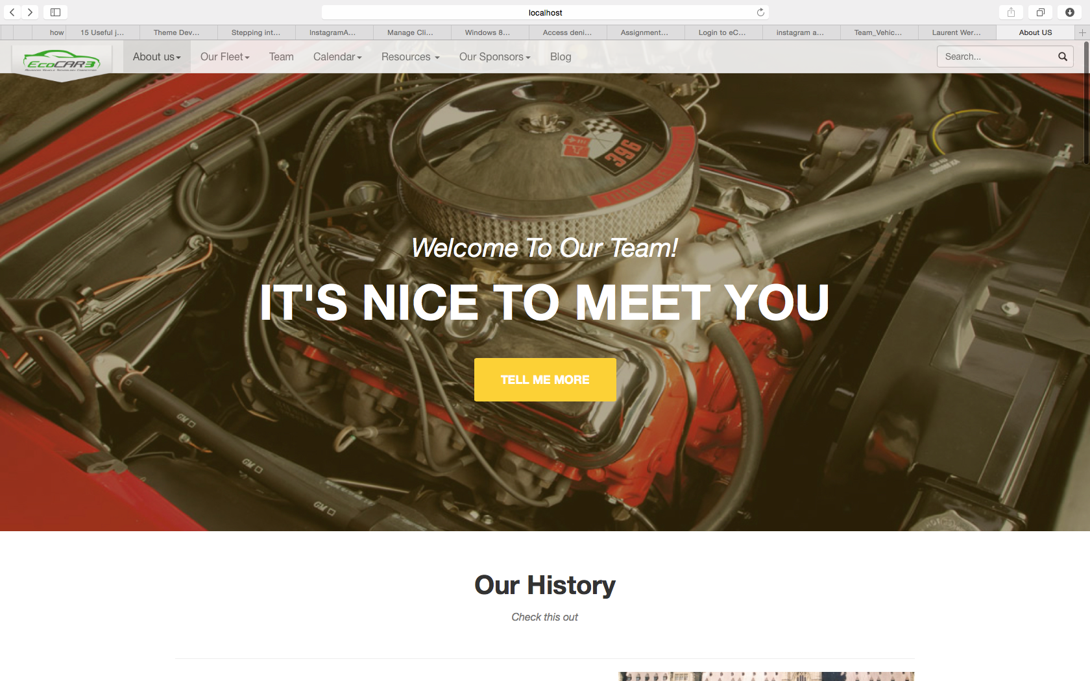

Page begins with a big picture, which is consistent design of the whole website. After introduction user navigates to the “History” part of the page.

**History part:**

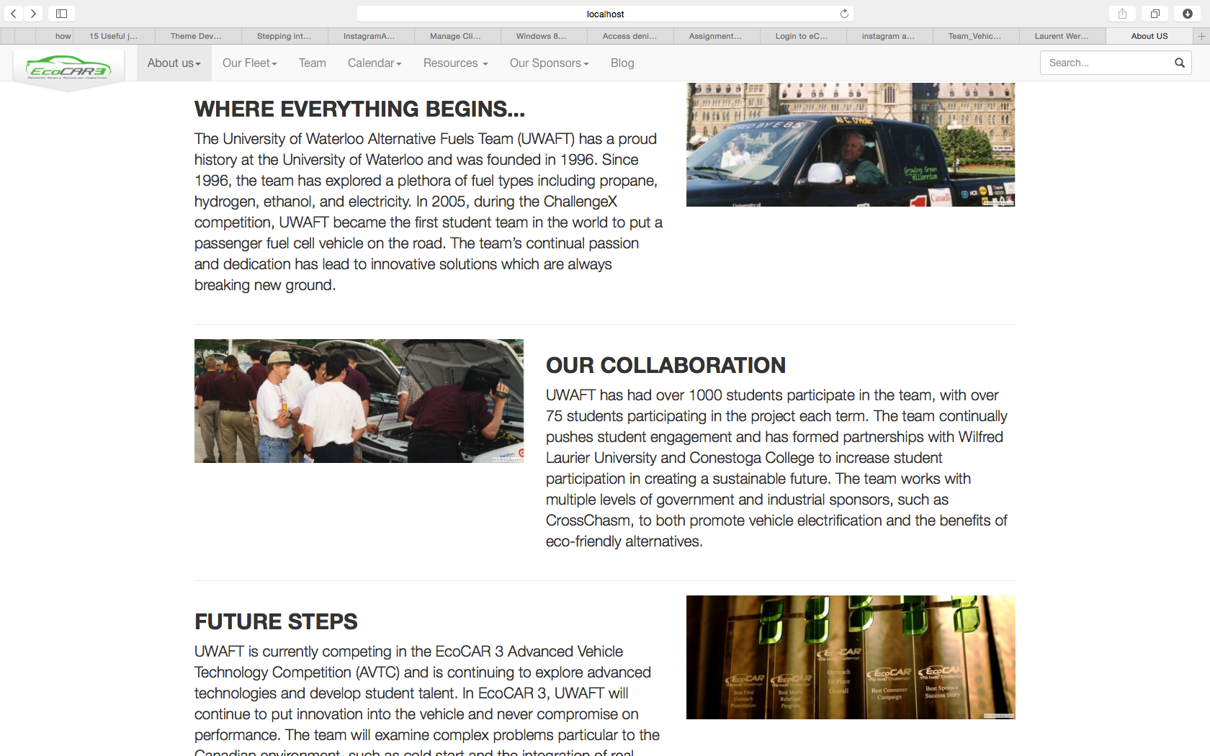

History part describes three main points about UWAFT with the pictures that add visual information to the topic. After user became familiar with the history, he/she may view easy structured time-line of the competitions participated by UWAFT:

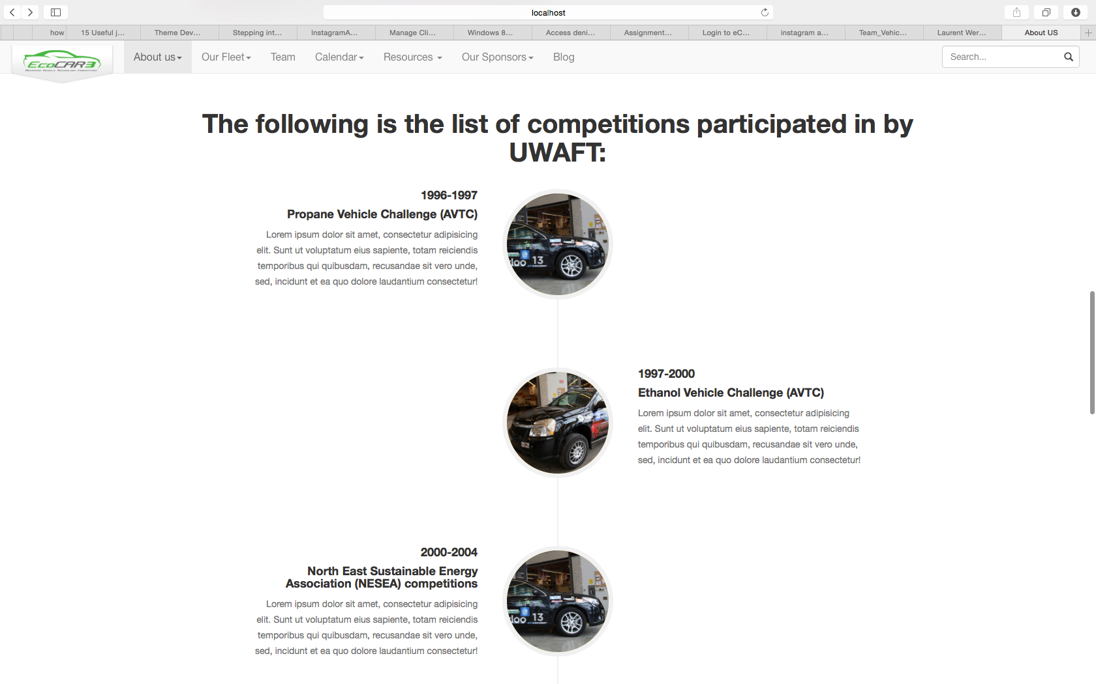

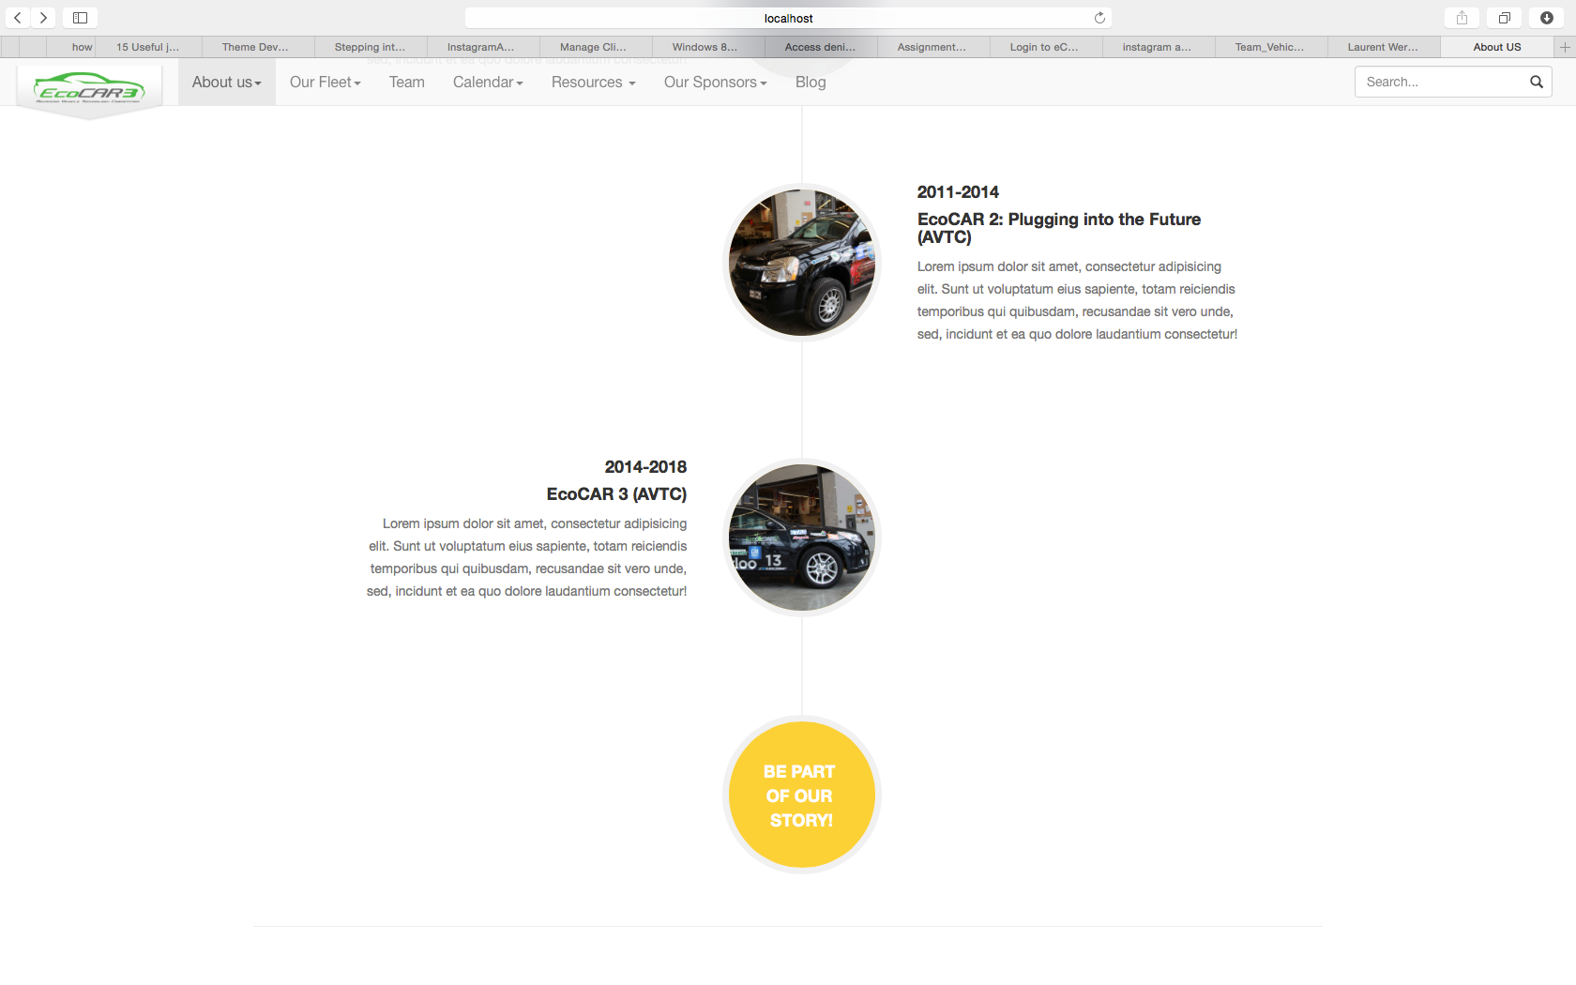

Finally, mission and vision of the company will conclude the whole previous information:

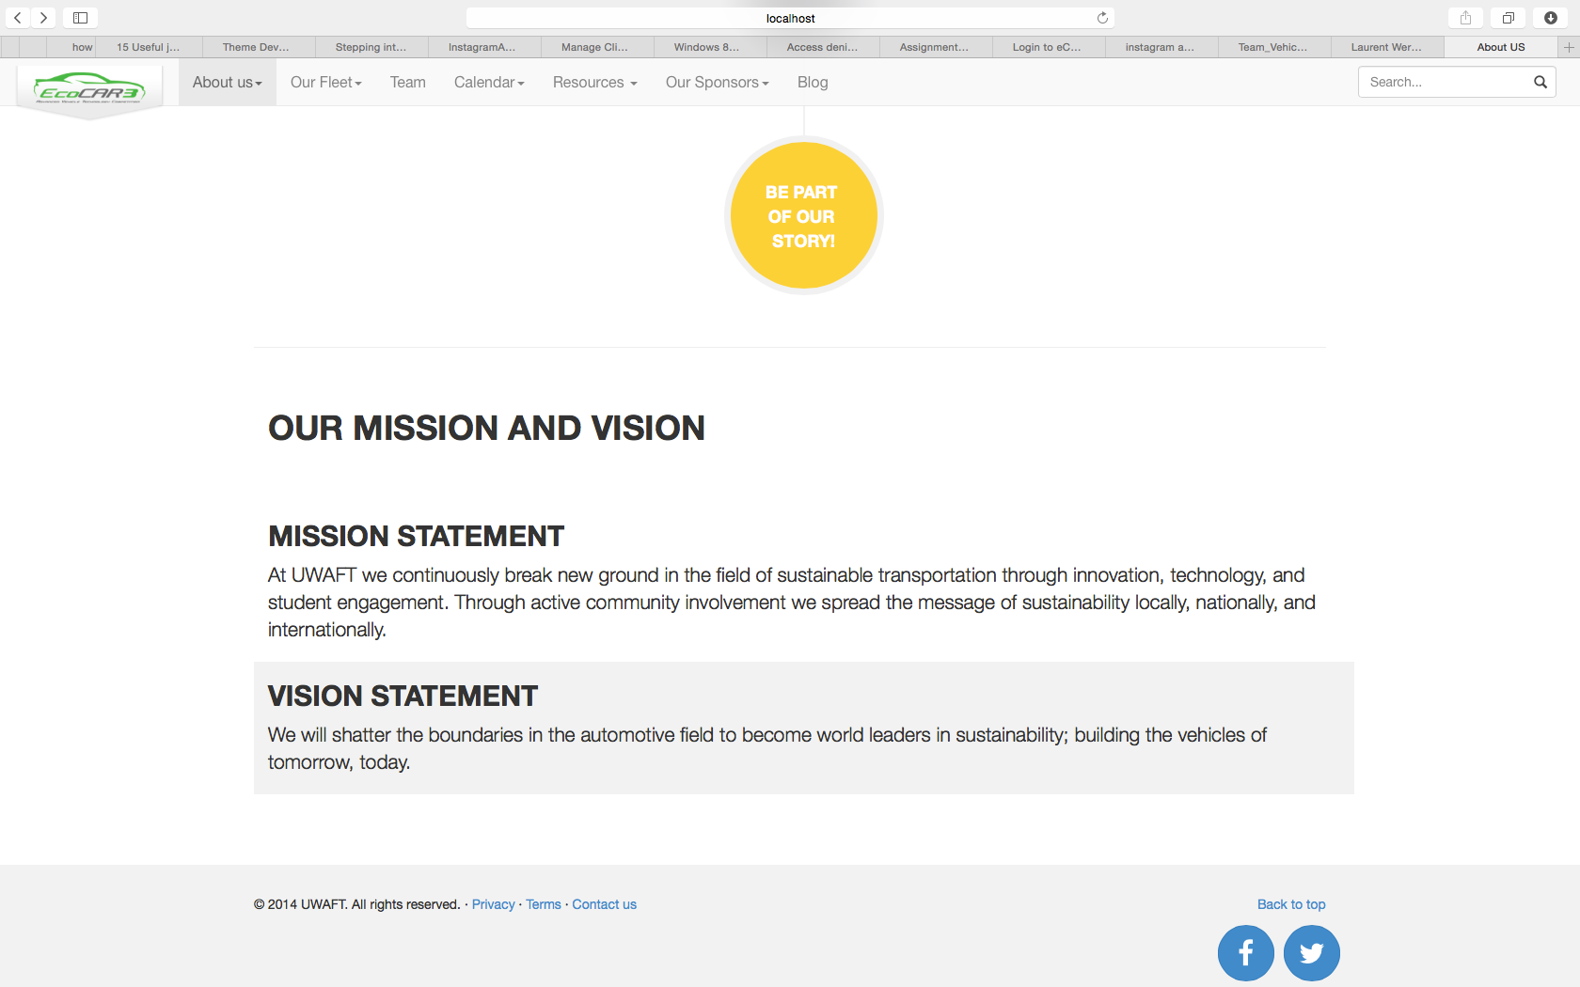

## Sponsorship page:

**Requirements:** Page that shows current sponsors as long with invitation to new with information about

**Technologies used:**

* PHP
* HTML5
* Bootstrap Framework
* Photoshop
* Illustrator
* CSS and JavaScript animation

**Page Author:** Alexey Rusev

**Overview:**

Page begins with the information about current sponsors. Header was made with the use of hover effect that will force user to stay on this page and play with it much longer than he would expect.

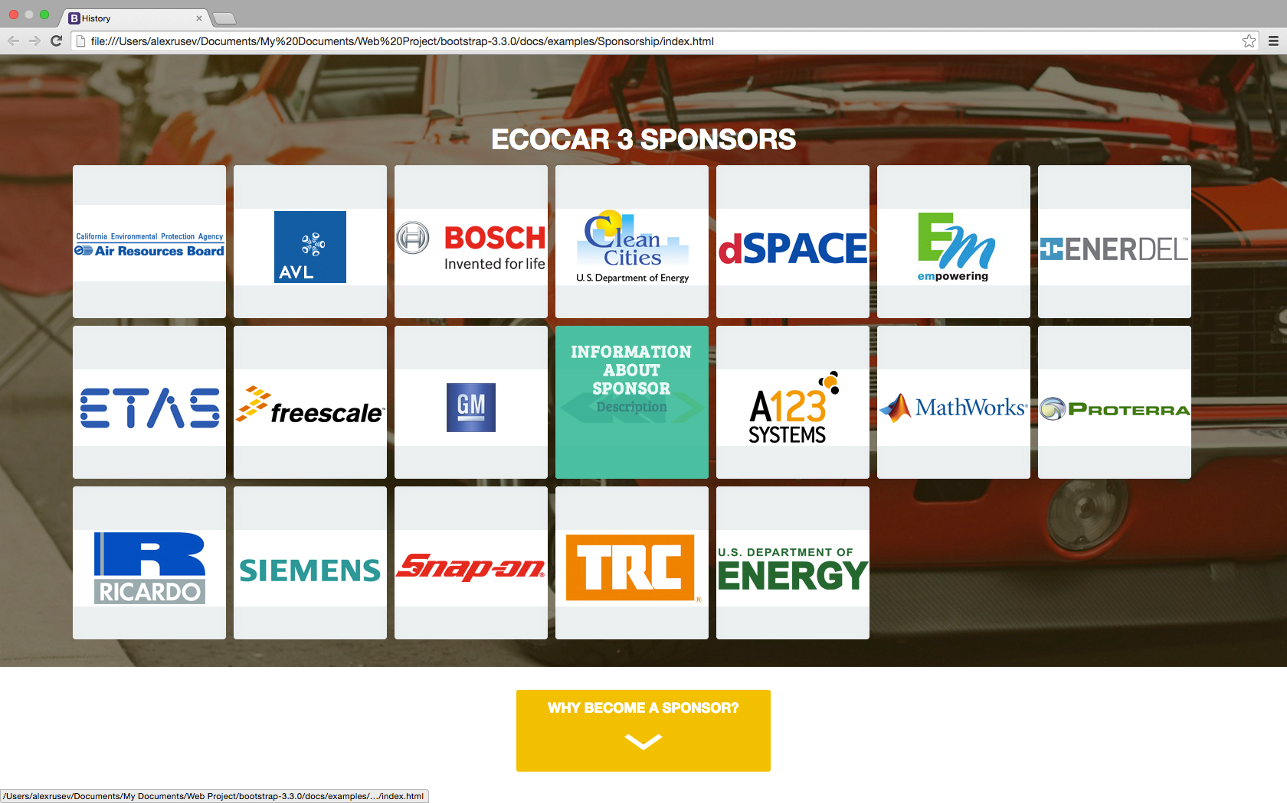

After user became happy by playing with hover on the first page and became ready to investigate to the project he/she may navigate to the next section, which will advice him/her about sponsorship opportunities and gives advantages of it in a well designed structure, as long with the information about local sponsors.

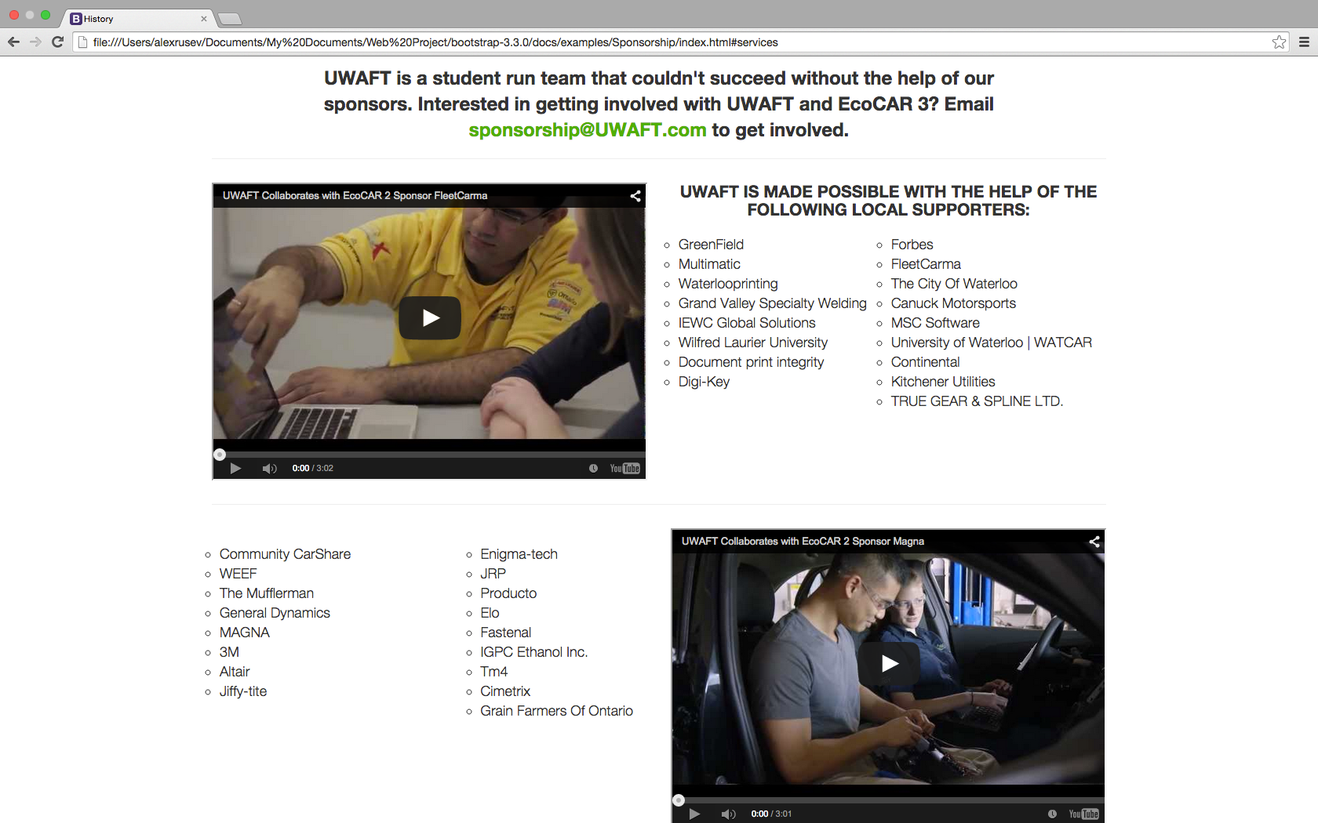

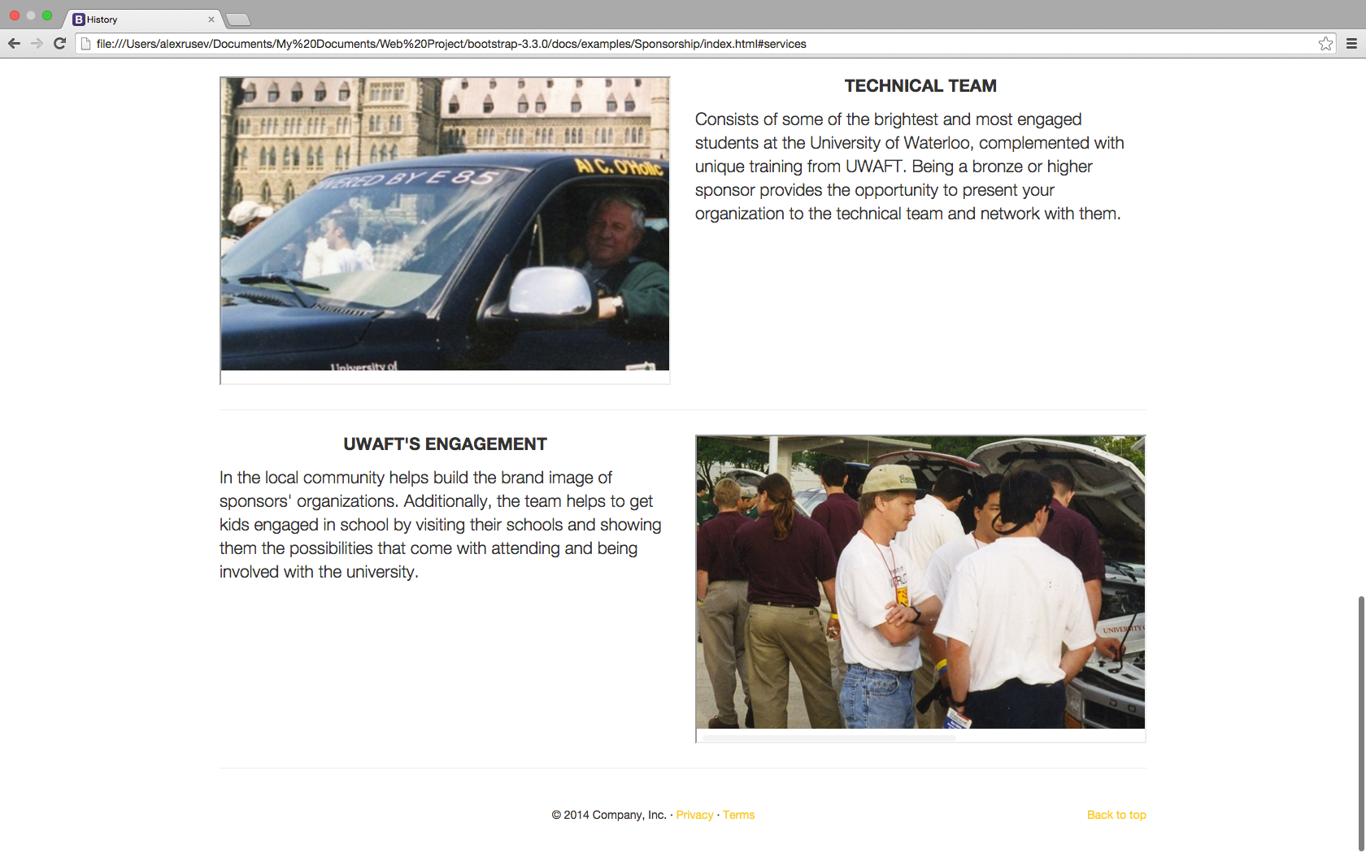

## The Vehicle Page: Our Fleet

**Requirements:** A page listing of the past vehicles.

1. 201? Chevrolet Camaro
2. 2013 Chevrolet Malibu
3. 2009 Saturn Vue
4. 2005 Chevrolet Equinox
5. 1999 Chevrolet Silverado

**Technologies used:**

* PHP
* HTML5
* Bootstrap Framework

**Page Author:**  Chanthida Pao

**Overview:**

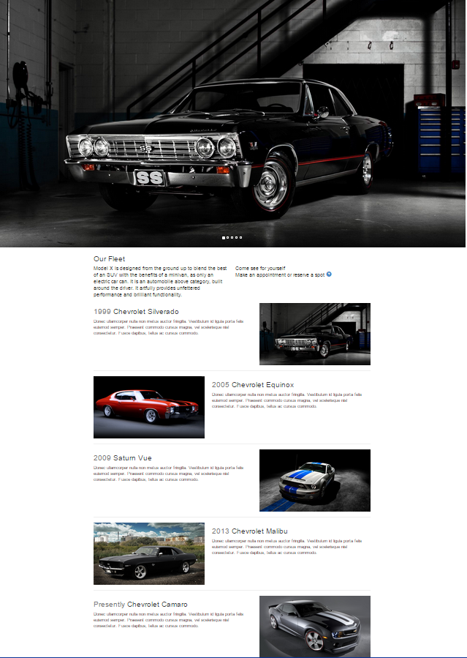

**Features:**

Carousal view of the vehicles featured. Placeholder images are used for now to represent the 5 vehicles in the requirements. The carousal will automatically scroll but the images can be manually changed with the right and left arrows on the sides of the image. The bootstrap carousal template was used to create this effect.

Introduction to the fleet is a short paragraph under the carousal images.

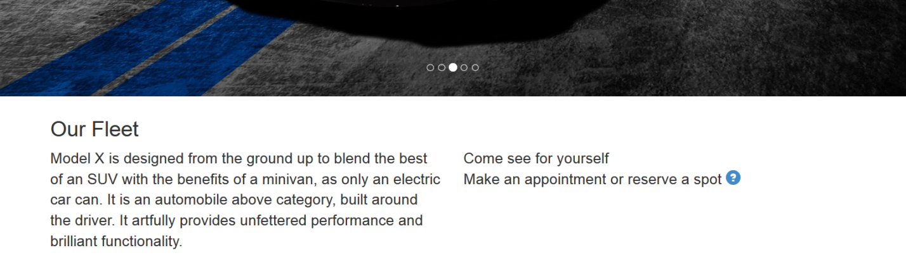

Timeline feature:

Vehicles are placed in a vertical line to represent time in a more visual appealing fashion. Inspired by the Facebook timeline the comments, which are lorem ipsum at the moment, are anchored to a line with car related Bootstrap glyphs.

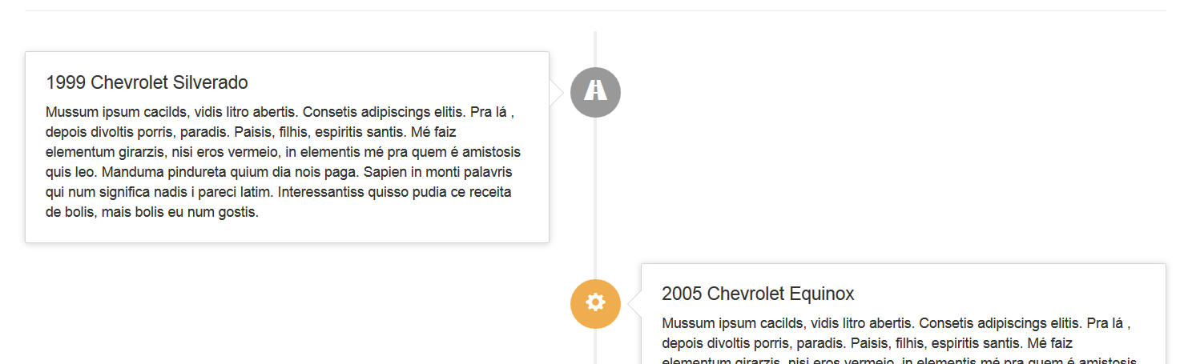

The vehicles are fully described in more detail: 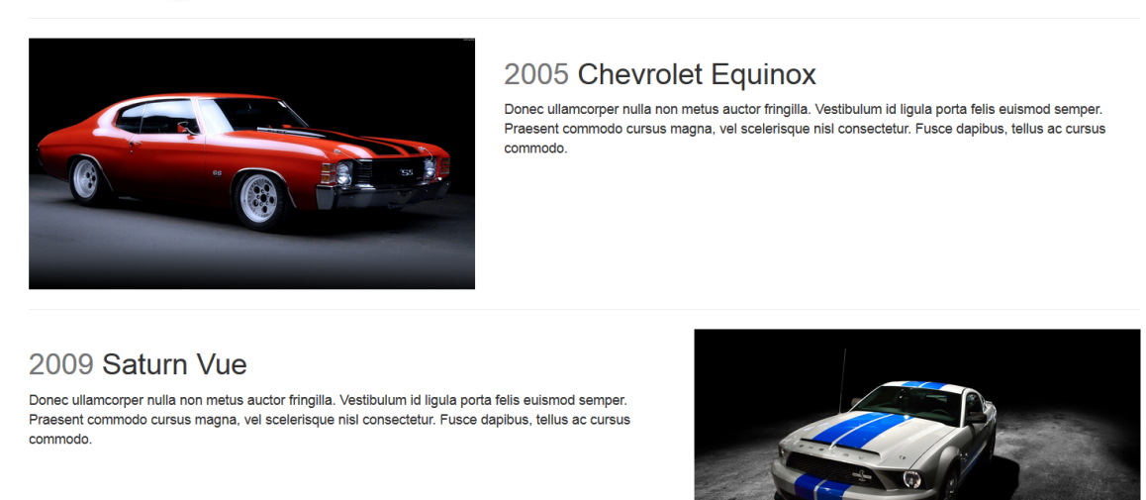

## The Team Page:

**Requirements:** The team should be a single tab. It should have a picture of the entire team and then underneath it a window that has tabs that could switch between: Technical, Project Management, and Communications. This is mostly for internal relations and to try to build a single unified team

Master team document provided with images.

**Technologies used:**

* PHP
* HTML5
* Bootstrap Framework
* MySQL
* CSS Animation

**Page Author**: Chanthida Pao

**Overview:**

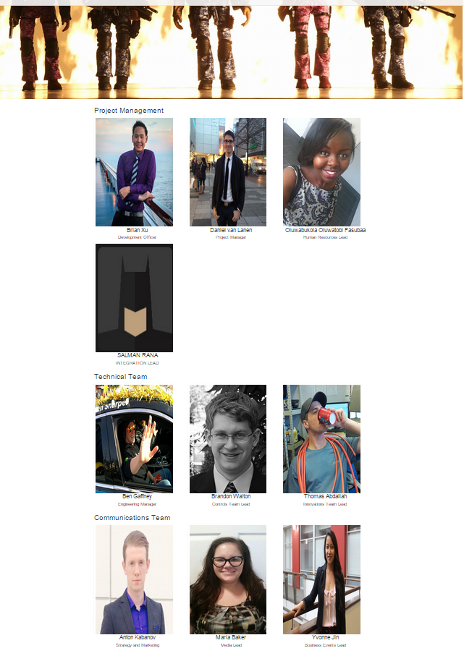

**Features:**

Picture of the entire team wasn’t provided and is currently a placeholder image.

Team members are divided into three categories; Technical, Project Management, and Communications. Each team member has their name posted with their position on the team page. Additional details are displayed with mouse over:

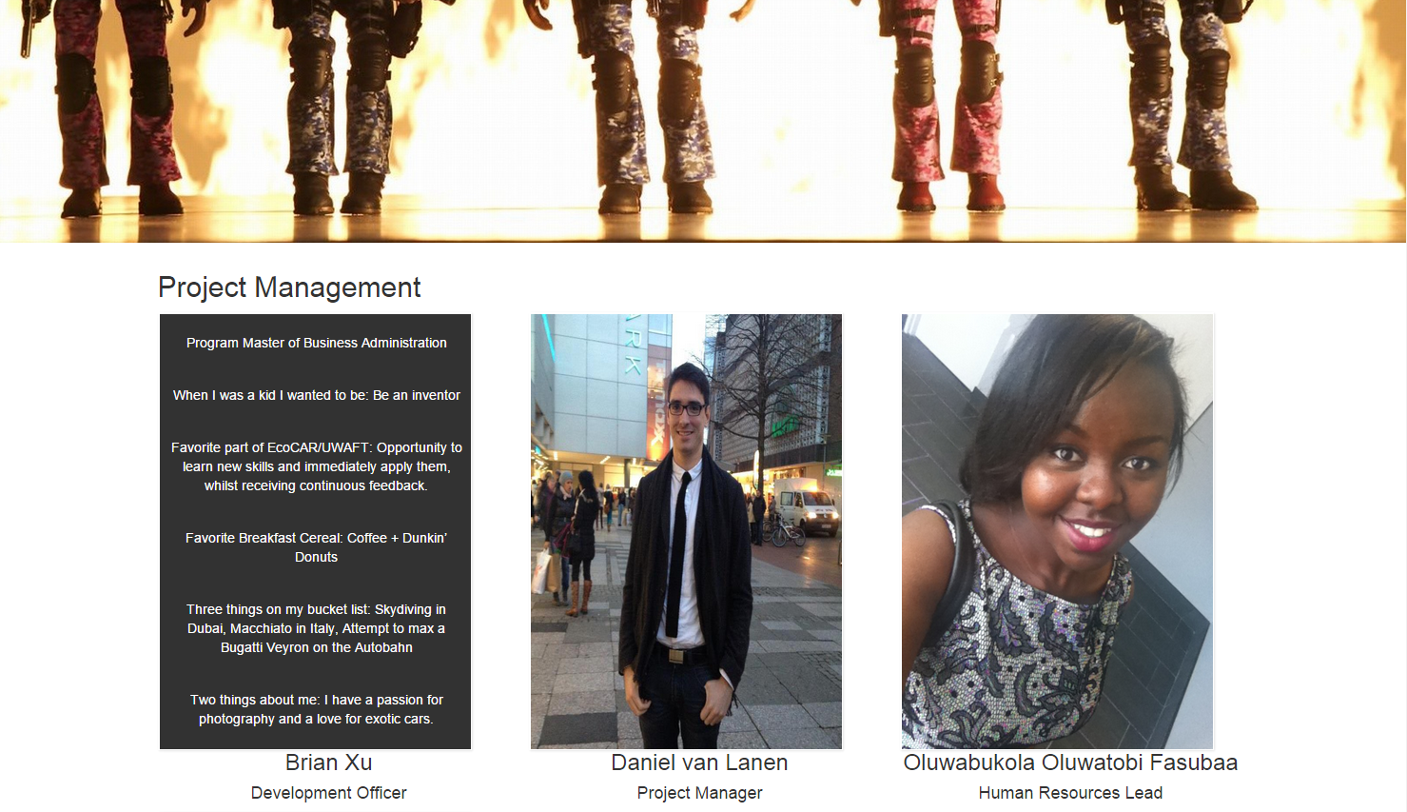

Members are managed on the team form page. This page holds the current team members in their respective categories and can be removed from the page if necessary. The form questions are based from the team master document.

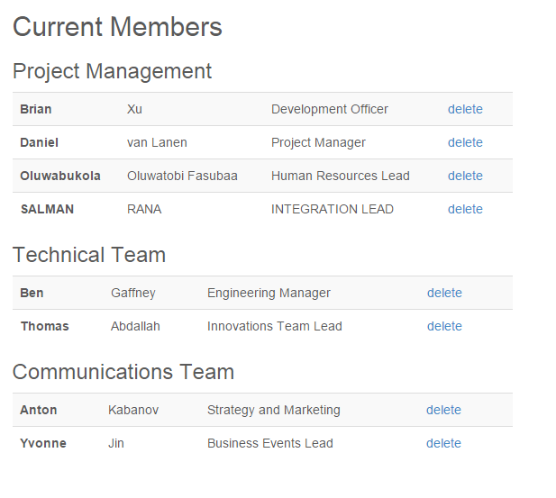

## Calendar

### Public Events

**Requirements:** A page listing all public events

**Technologies used:**

* PHP
* HTML5
* Bootstrap Framework
* jQuery
* Some other third party resources

**Page Author:**  Weiwei Chen

**Overview:**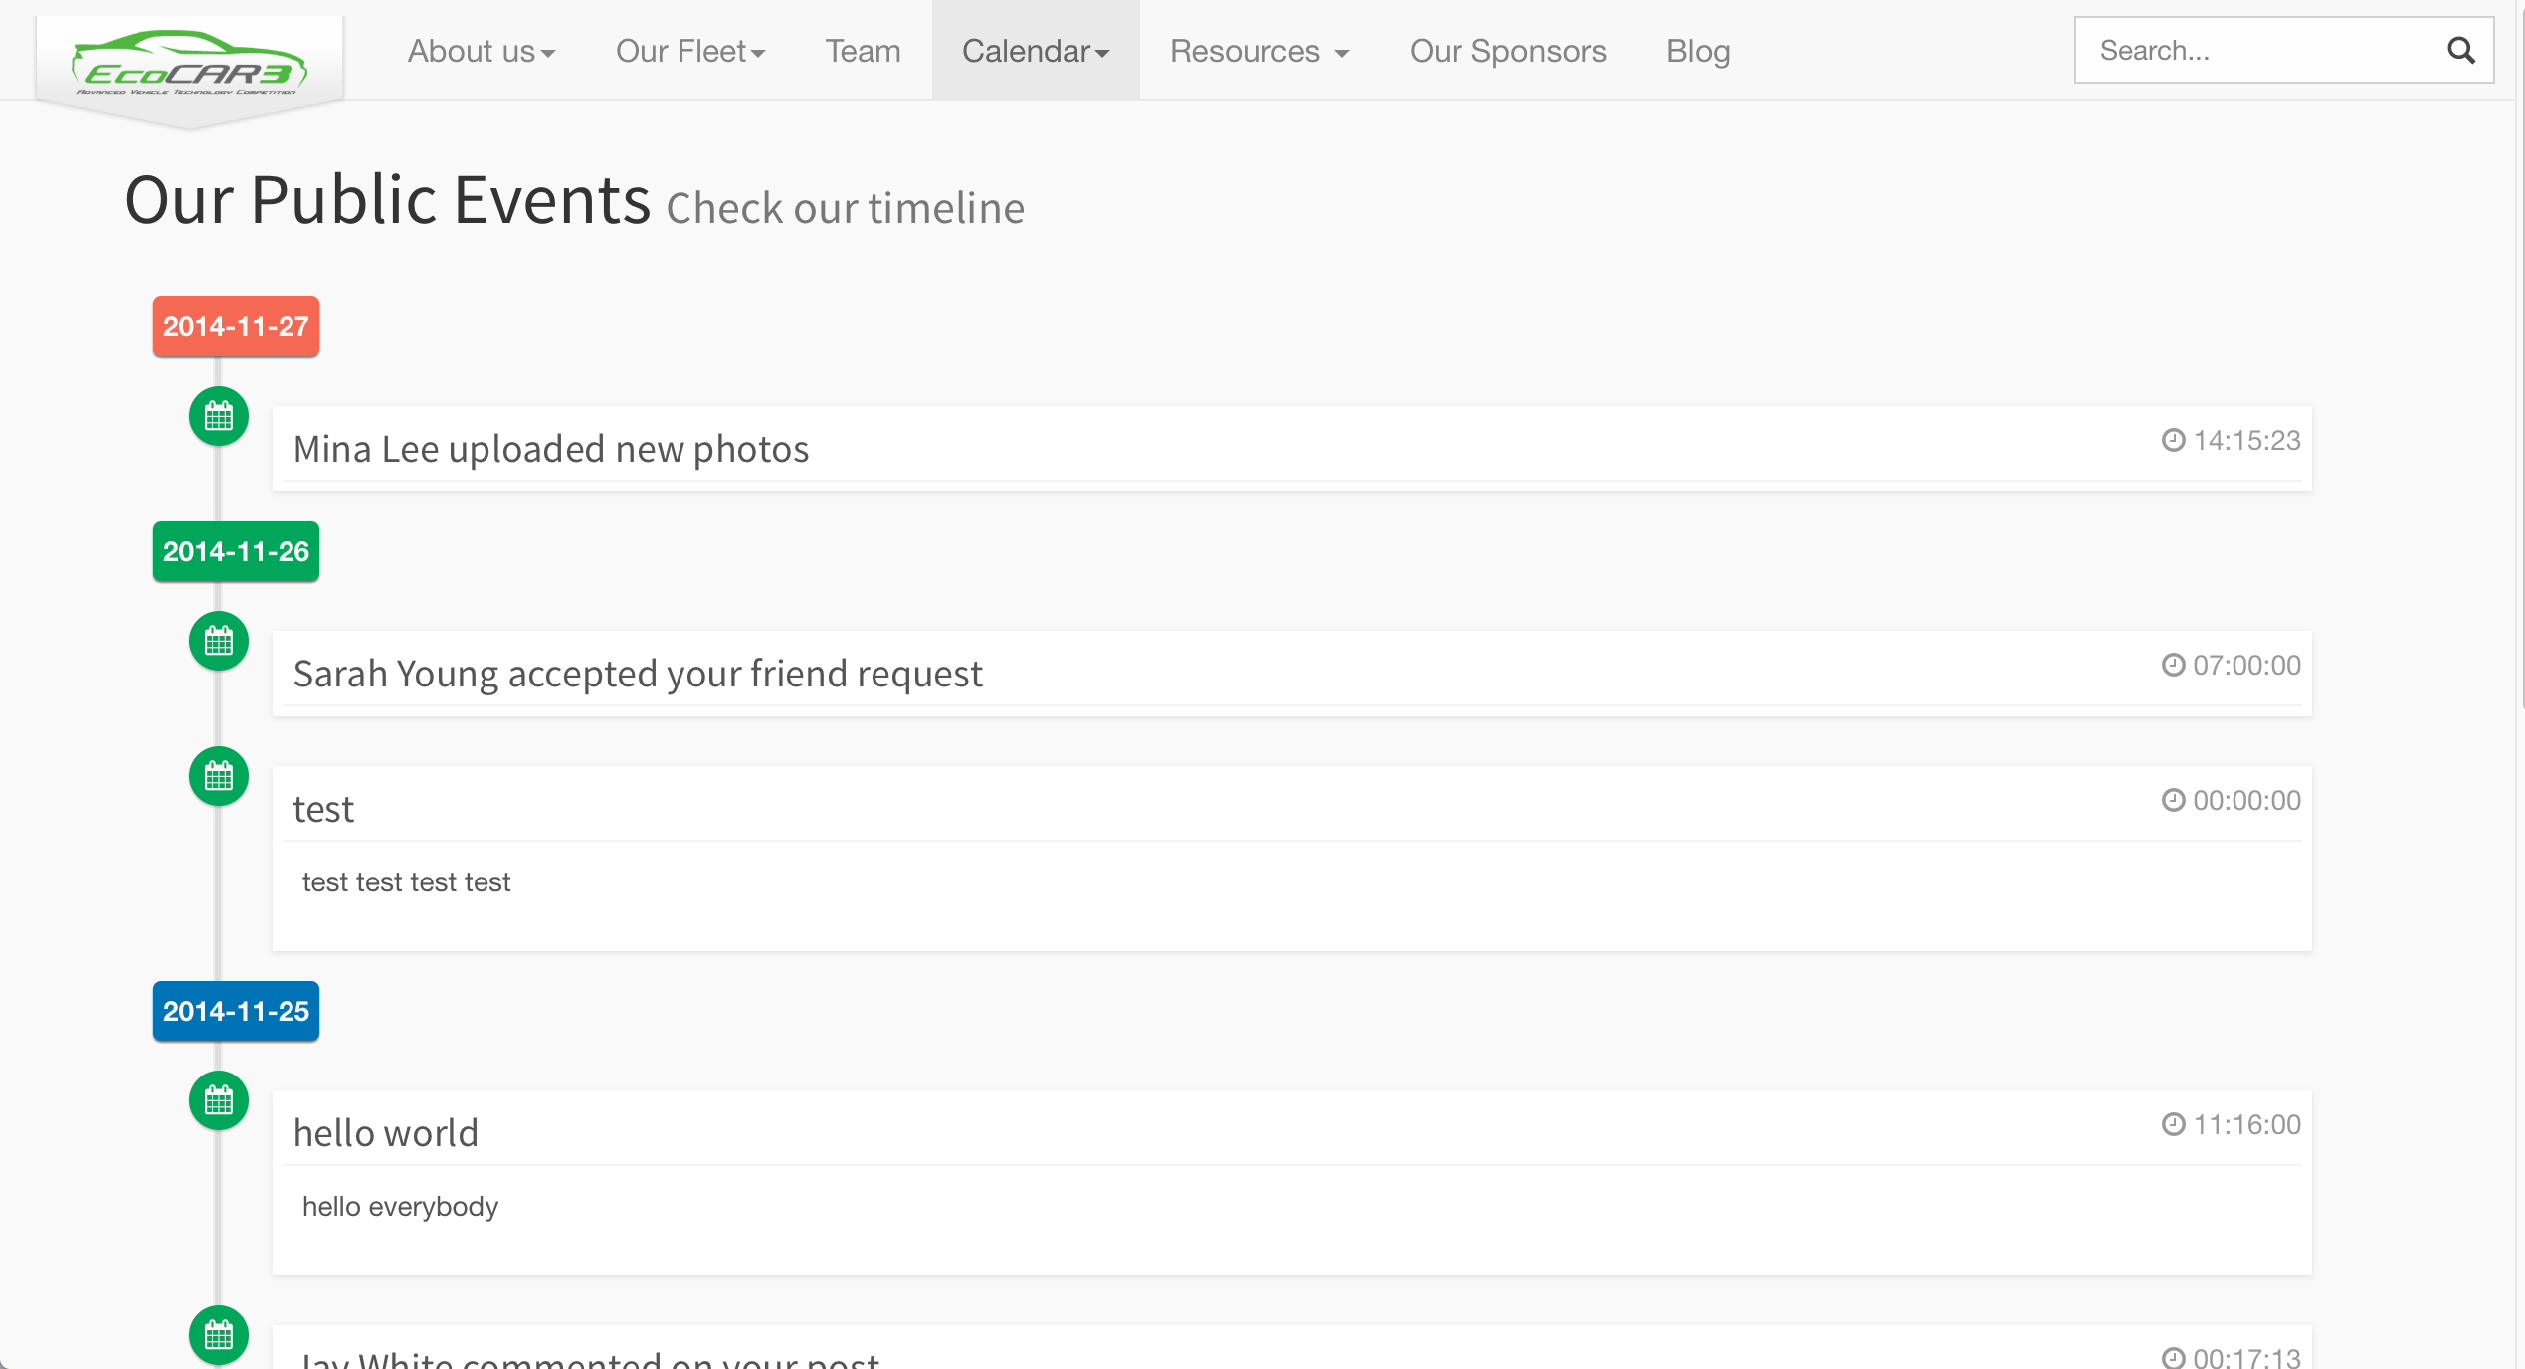

**Features:**

A timeline view to show all events in a vertical sequence in date reversed order. The events that in the same day are grouped in a section and each day is a different section.

According to requirements, each event has title, message, date and time information.

### Team Schedule

**Requirements:** A calendar that shows all team schedules

**Technologies used:**

* PHP
* HTML5
* Bootstrap Framework
* jQuery and jQuery-UI
* Ajax
* Some other third party resources

**Page Author:**  Weiwei Chen

**Overview:**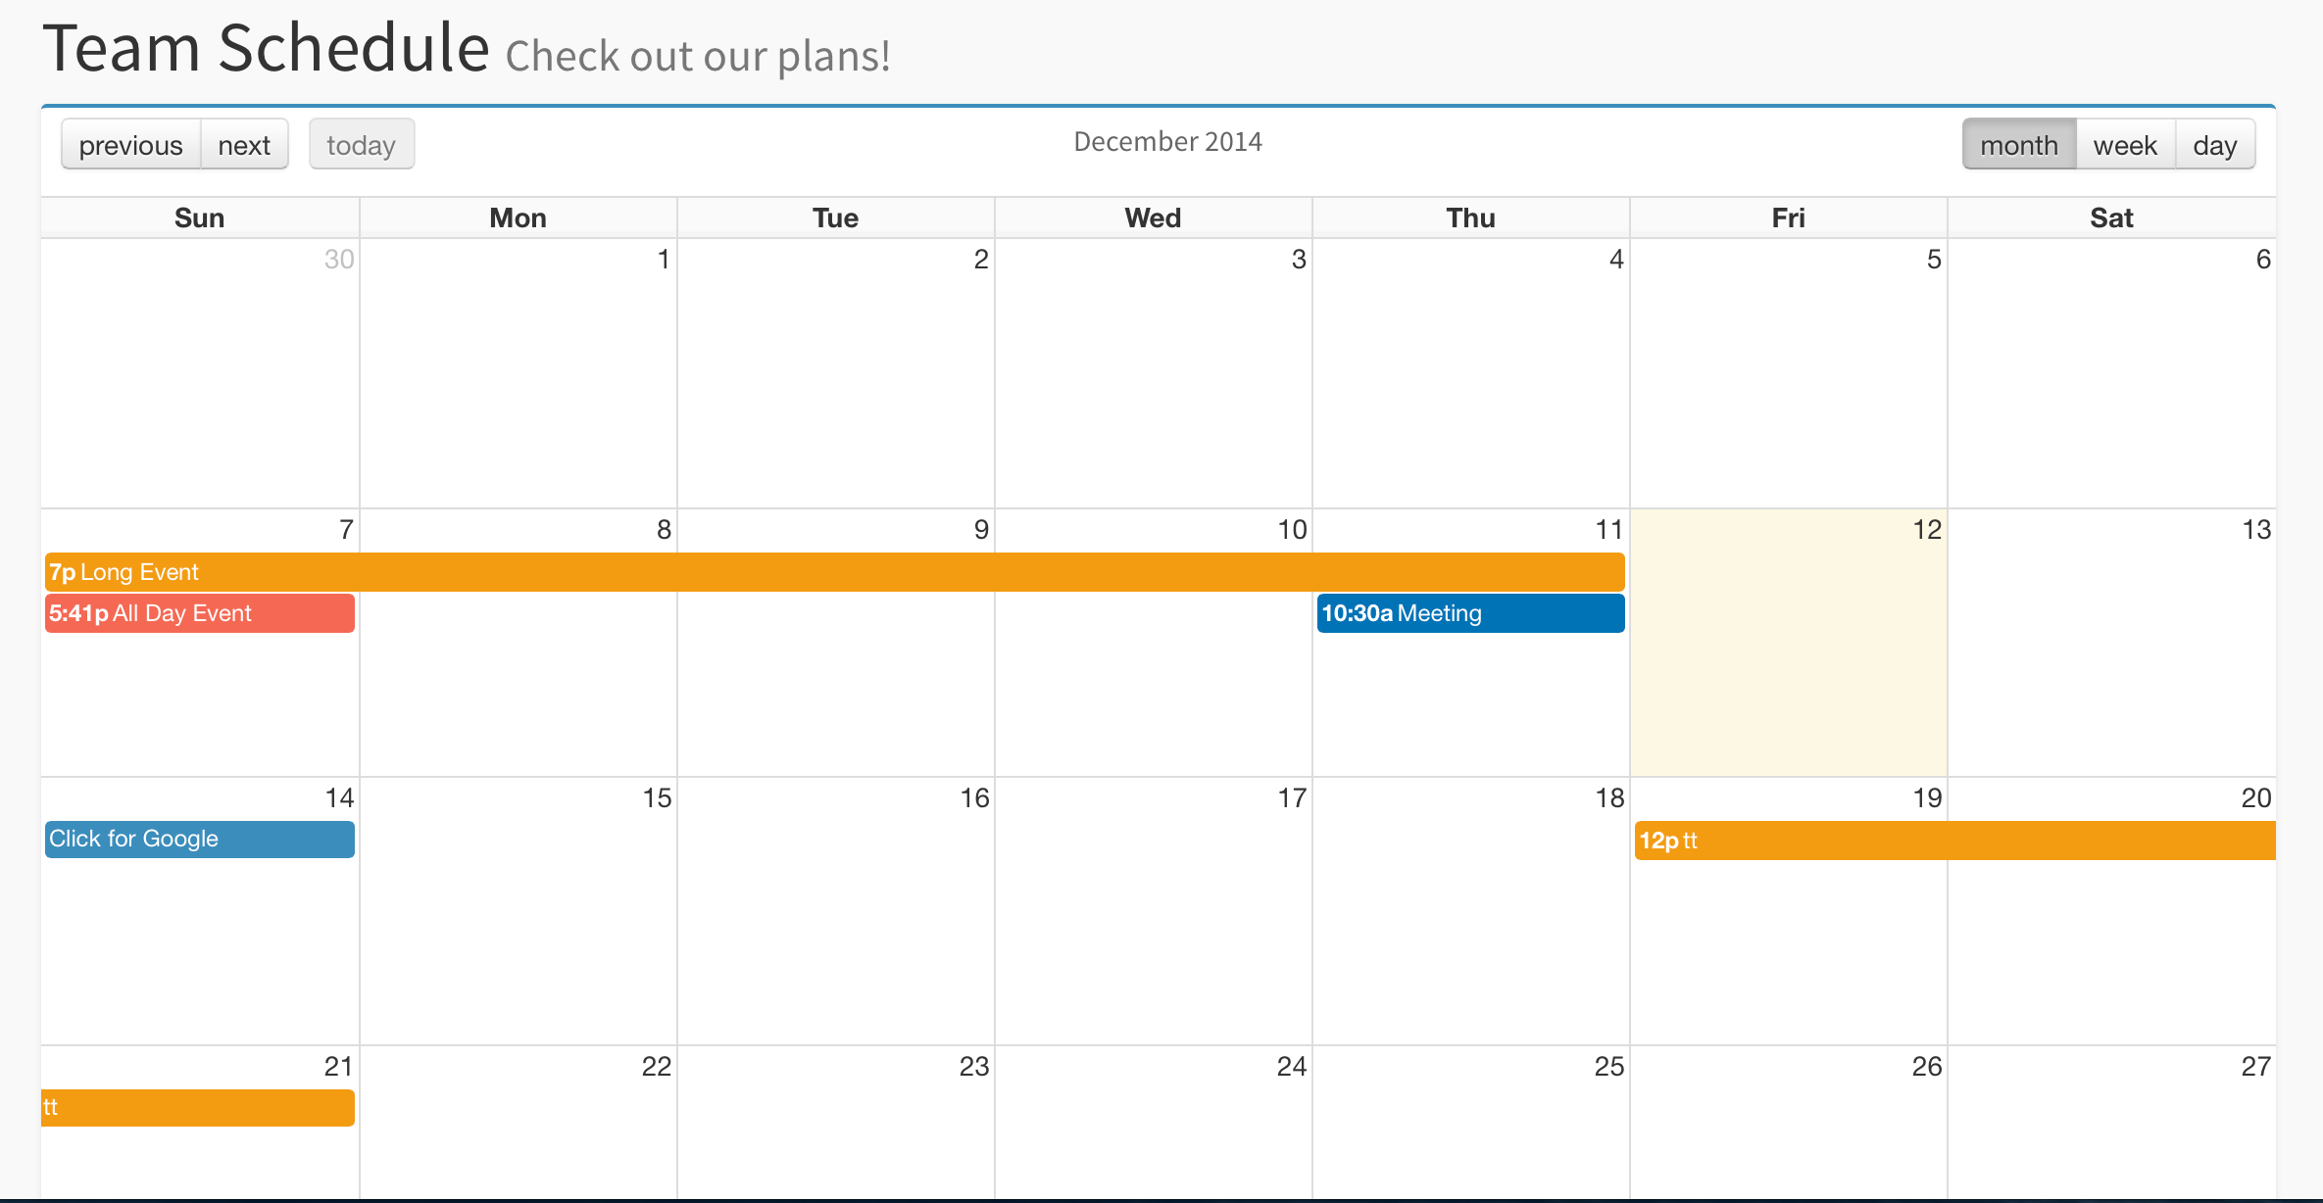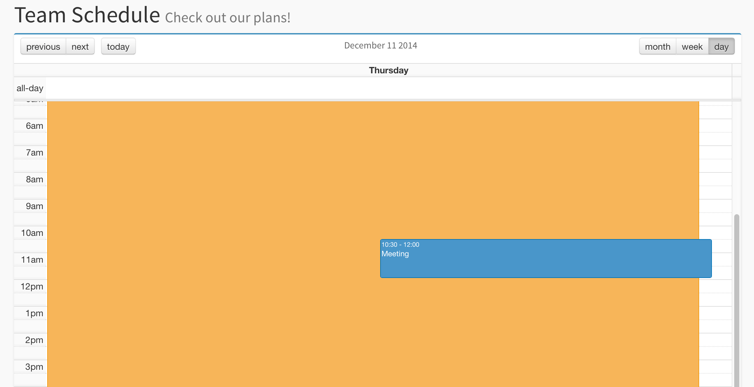

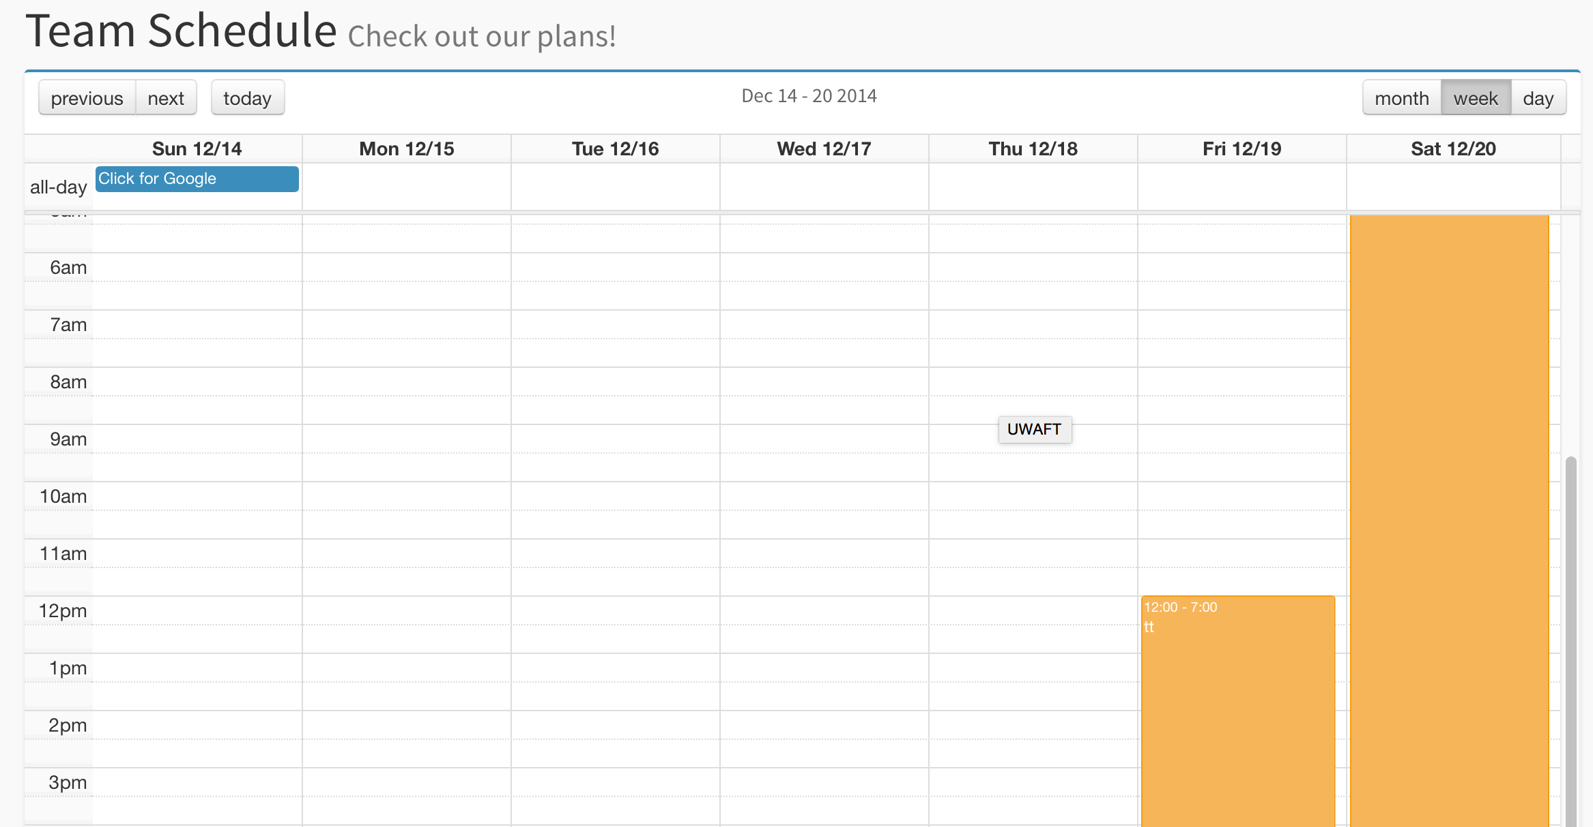

**Features:**

A iPad Style calendar view to show team schedules. The schedules are ordered in month, week and day view.

Each schedule event has title, start date and time, end date and time, url (clickable link), all day (is the event for the whole day) and colour for the event.

## Resources

### Savings Calculator

**Requirements:** A calculator to compare benefits of different cars

**Technologies used:**

* PHP
* HTML5
* Bootstrap Framework and a Bootstrap Slider
* jQuery
* Some other third party resources

**Page Author:**  Weiwei Chen

**Overview:**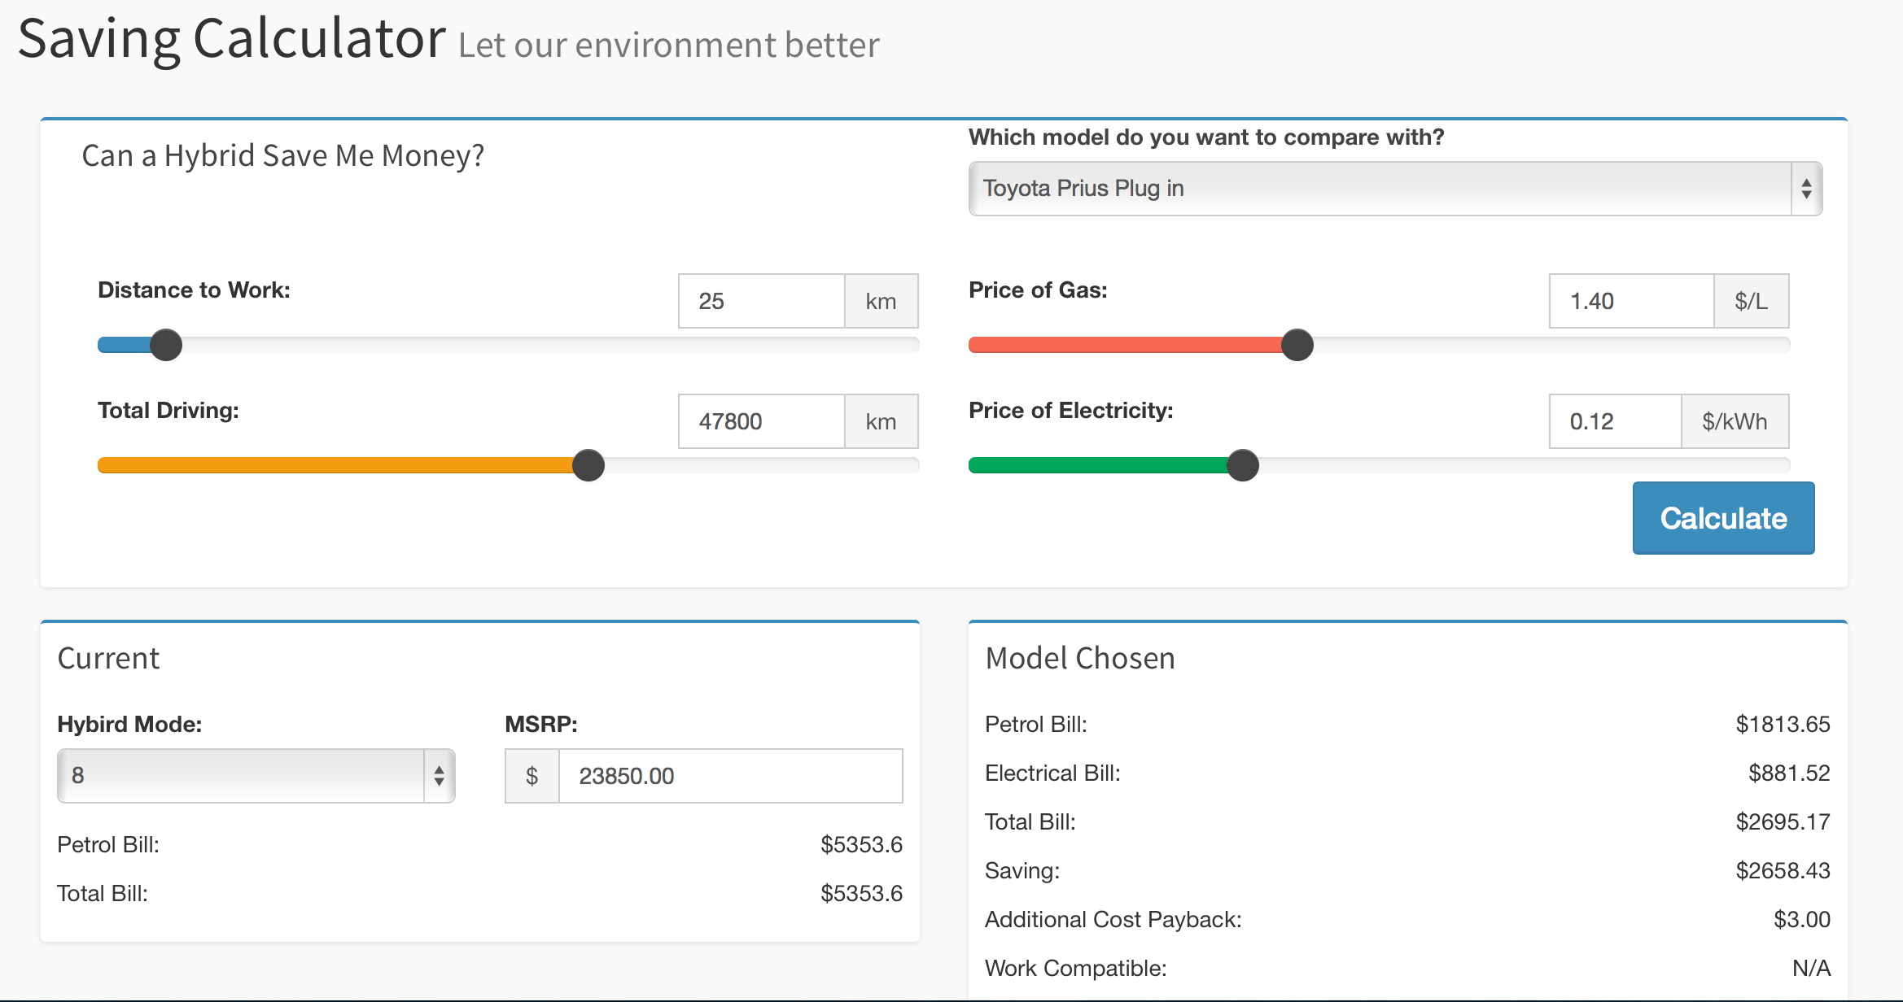

**Features:**

A simple calculator to compare the current car and other competitor’s car in terms of petrol and/or electric bill, saving and other benefits.

There are some values can be inputed by user: distance to work, total driving, gas price and electricity price. Hybrid model and MSRP for current car are also editable.

## Blog

**Requirements:** A blog for UWAFT members

**Technologies used:**

* Wordpress
* Bootstrap Framework

**Page Author:**  Weiwei Chen

**Overview:**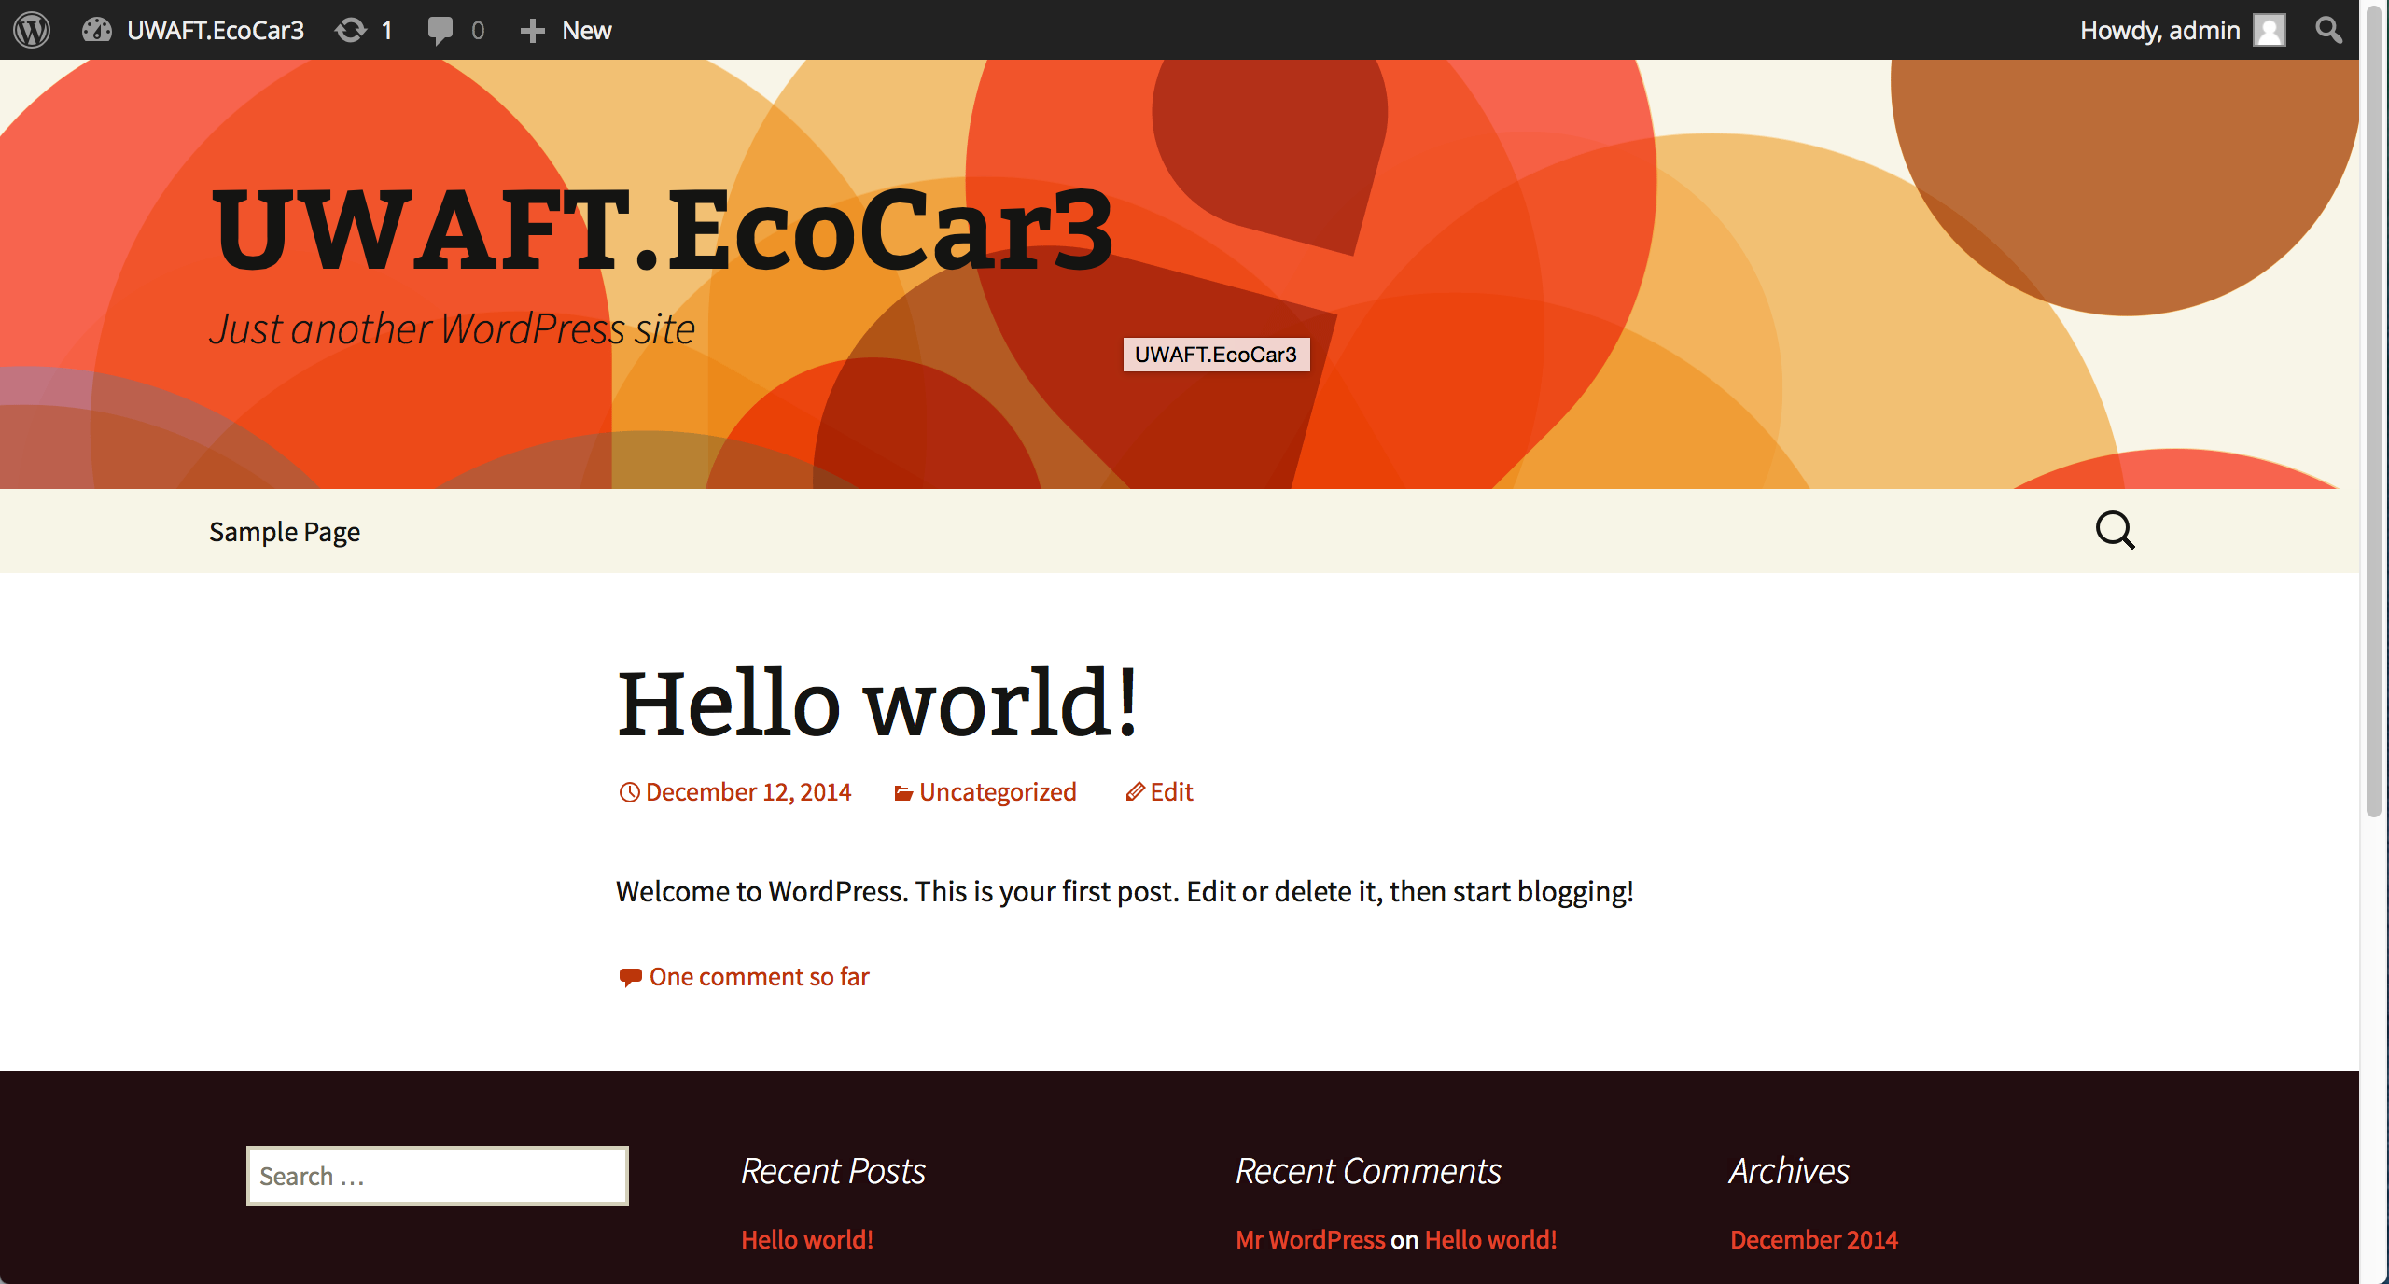

**Features:**

A simple blog that allows UWAFT members to post articles.

## Admin

The admin page that to manage Calendar and team page.

**Technologies used:**

* PHP
* HTML5
* Bootstrap Framework and a Bootstrap Slider
* jQuery and jQuery-UI
* AdminLTE framework
* Some other third party resources

**Overview:**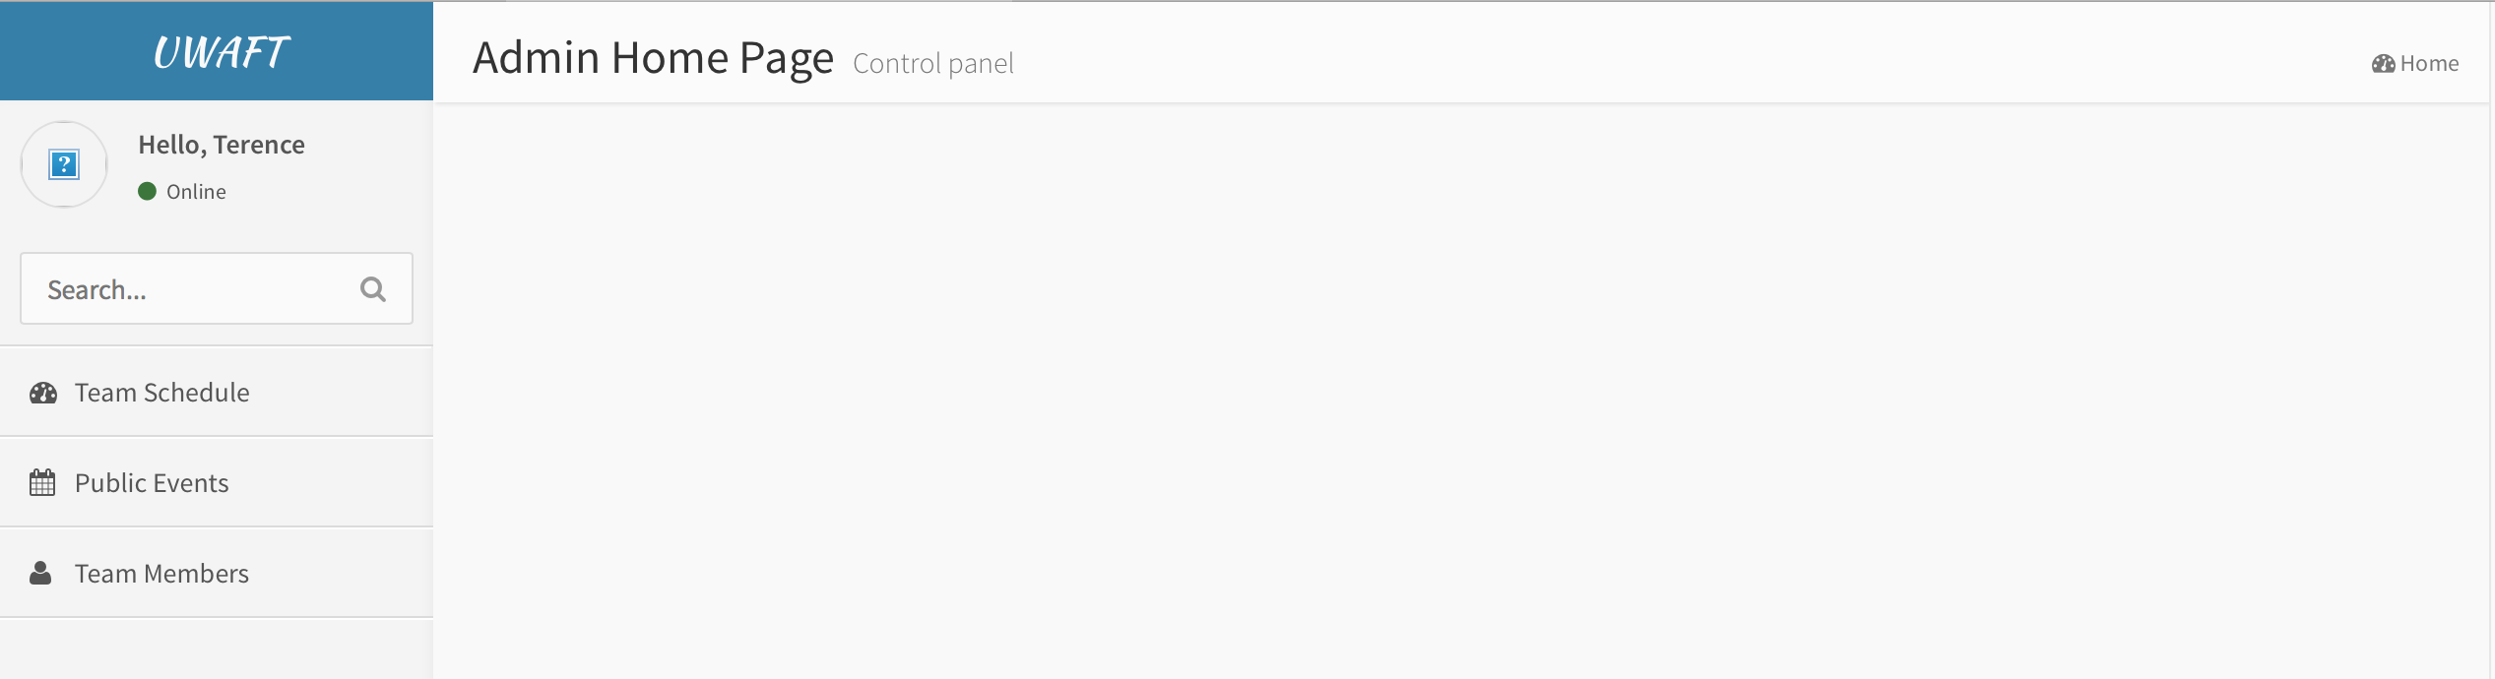

**Features:**

The admin page that organize all back-end management features. There is no login or register function for admin page yet, so it can be directly opened.

## Team Schedule

**Requirements:** The management page of updating team schedules

**Page Author:**  Weiwei Chen

**Overview:**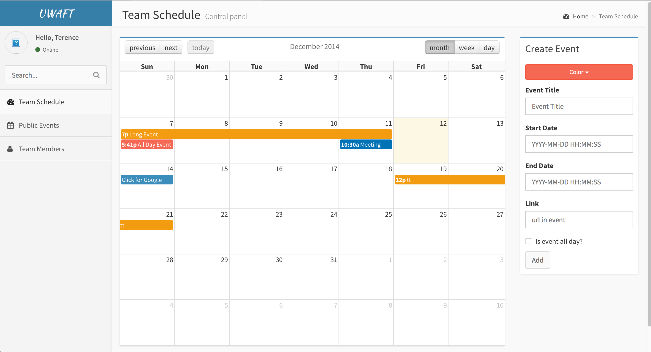

**Features:**

The page to manage team schedules. However, there is only add new schedule function, update and delete functions are not available yet.

## Public Events

**Requirements:** The management page of updating public events

**Page Author:**  Weiwei Chen

**Overview:**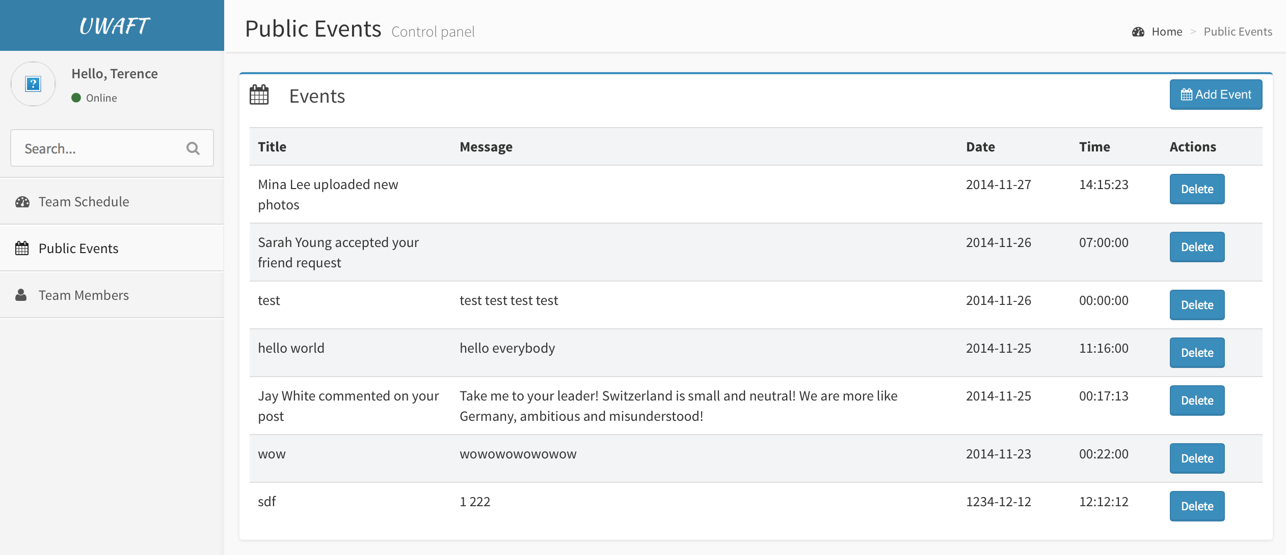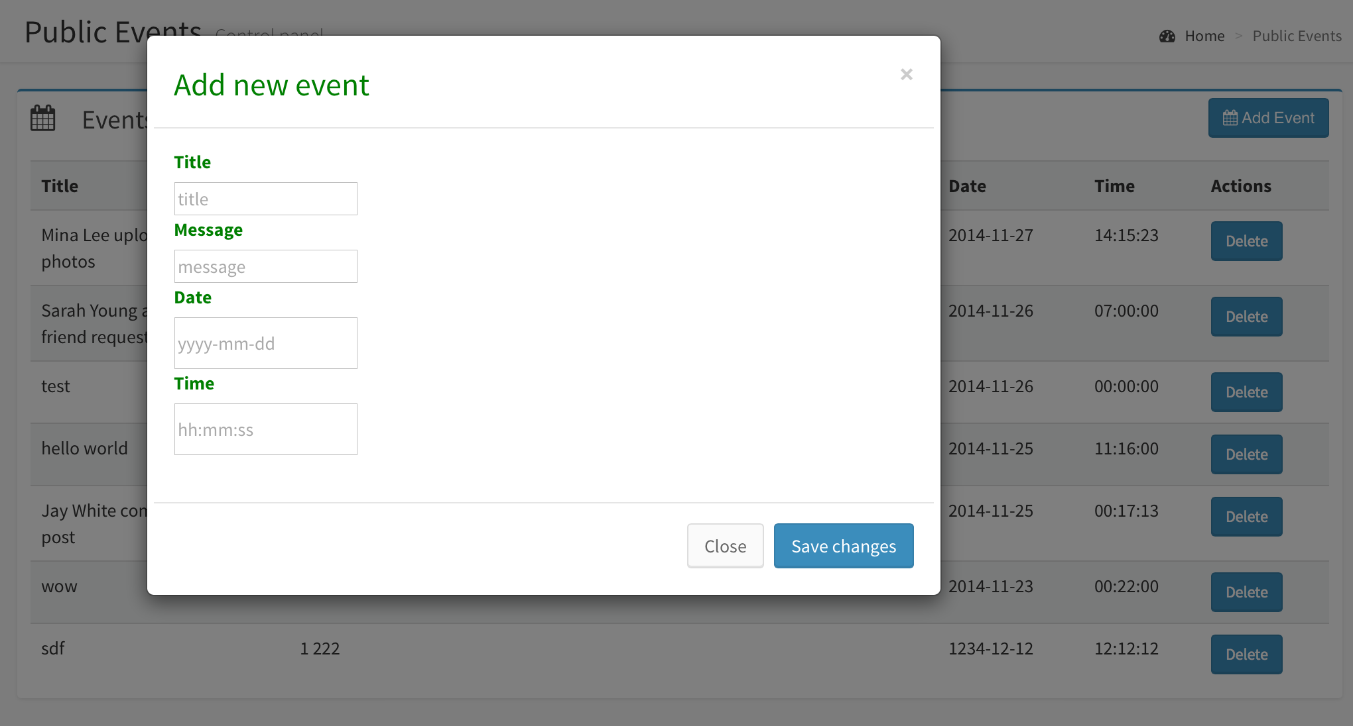

**Features:**

The page to manage public events. It can add and delete events. Updating is not yet supported.

## Team Member

**Requirements:** The management page of updating team members

**Page Author:**  Chanthida Pao

**Overview:**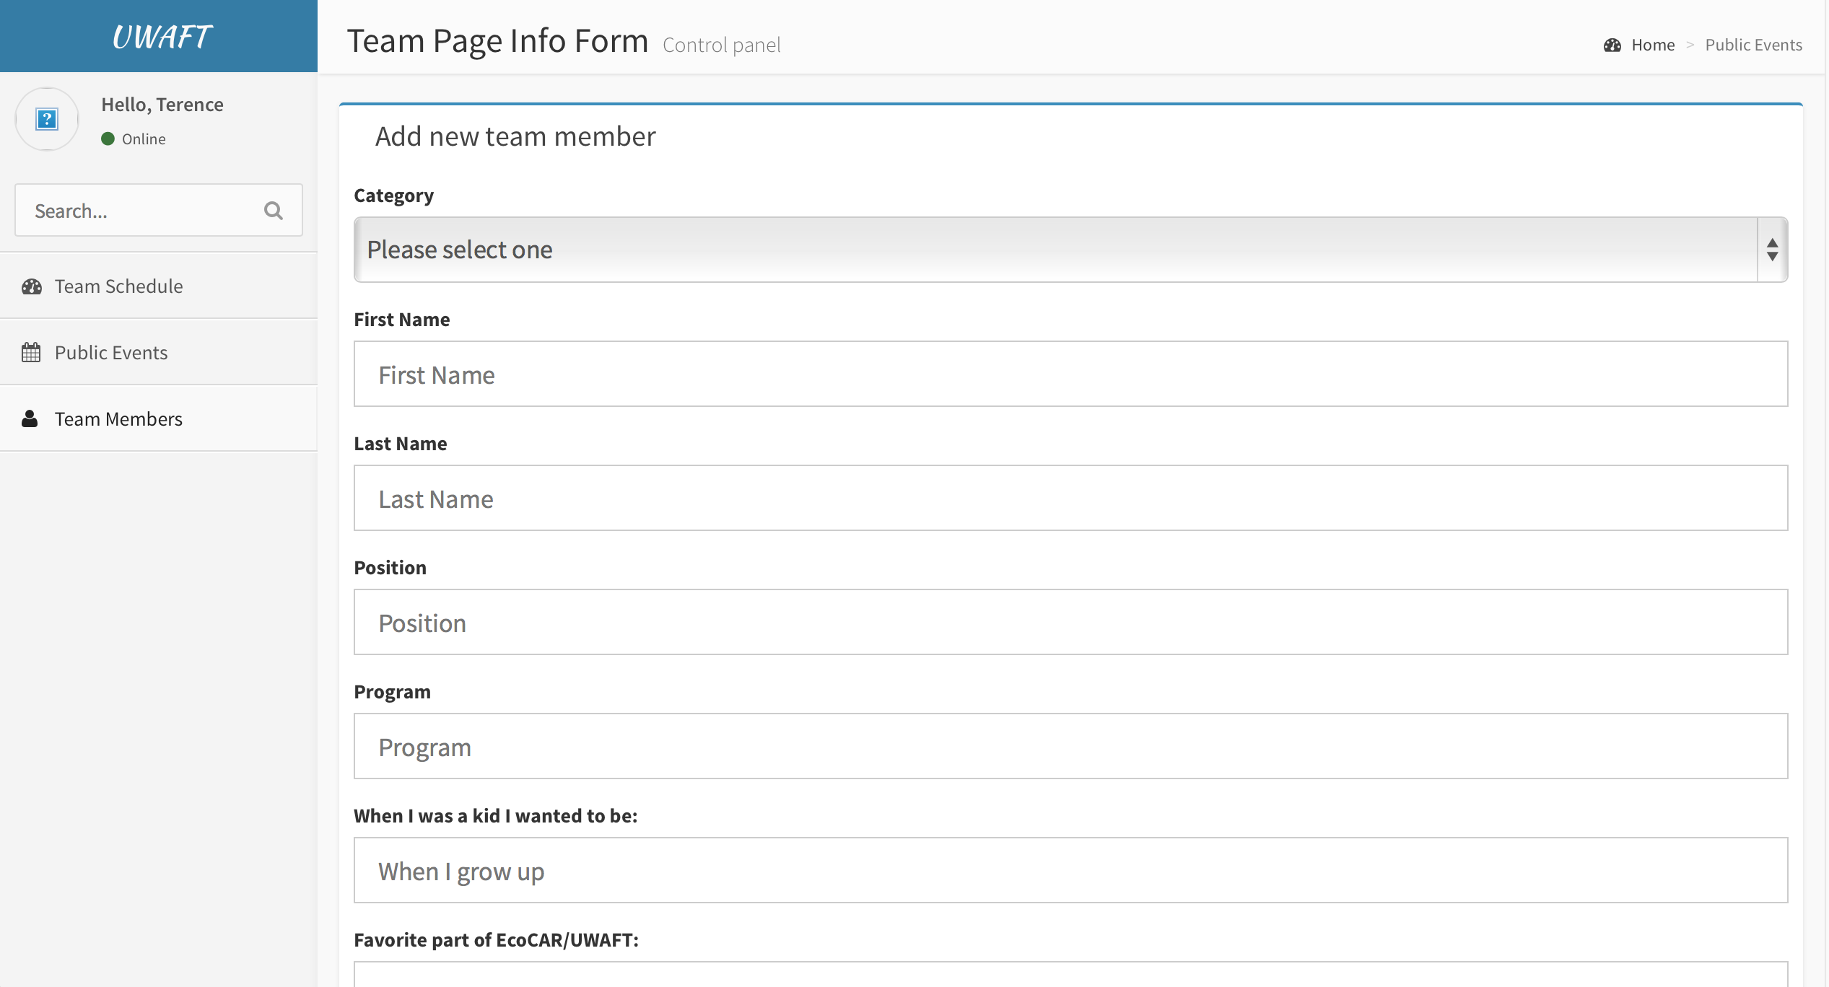

**Features:**

The page to manage team members. It can add and delete members.

## User Manual

### **Installation**

1. Copy the root folder "UWAFT" into web server and set it as the server root folder or copy all files inside to the server root folder
2. Import Database file - Open the server database (MySQL for example), direct to "Import" tag and select import from file, select file "UWAFT.sql" in "database" folder inside the root folder. Before doing that, make sure there is no existing database named "UWAFT", delete it if there is any.
3. Go to includes/databaseConnection.php and admin/includes/databaseConnection.php and change "server", "username" and "password" variables inside to your server setup
4. Open Blog and it will direct you to setup page for wordpress, input all necessary information there such as database name(whatever you like), server admin account.
5. Congratulation, it is all done, you are ready to launch the website now.

### File hierarchy Introduction

* All page files are named according to their features like aboutUs.php is for About Us page.
* admin: this folder contains all admin management pages such team schedule management page
* bootstrap: this folder contains the Bootstrap framework
* css: this folder has all css file used by pages
* database: there is a UWAFT.sql database file inside
* documents: it includes all documentation including this document
* Fonts: all extra font files
* images: all images used by pages
* includes: some php common used files like header and footer
* js: all javascript files and some frameworks like jQuery
* wordpress: the whole WordPress framework inside